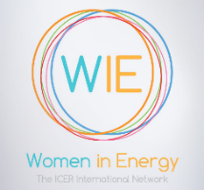
WIE APPLICATION FORM

W
ICER’s WIE network is open to all staff (men and women) of national/state/regional regulatory authorities who are members of the International Confederation of Energy Regulators (ICER).
Please complete the following fields:

PERSONAL INFORMATION
First name
Click here to enter text.

Birth Date
Click here to select a date.

Personal E-mail
Click here to enter text.

JOB INFORMATION
City, Country
Click here to enter text.

Organization
Click here to enter text.

Experience years in the energy field
Click here to enter text.

SOCIAL MEDIA INFORMATION
Twitter account
Click here to enter text.

Other social media accounts
Click here to enter text.

Last name
Click here to enter text.

Gender
Choose an option.

Corporate E-mail
Click here to enter text.

Job position
Click here to enter text.

What ICER member does your organization belong?*
Choose an option.

LinkedIn account

Click here to enter text.

